|  |  |  |  |  |  |
| --- | --- | --- | --- | --- | --- |
| Date | 1-Dec-22 | | | Tester Name | Andrew McLaughlin |
| Environment | Penfax - Test | | | Login used |  |
| Operating System | Select OS | Version: | Update: | | |
| Software Used | Select Software | Version: | Update: | | |
| Select Software | Version: | Update: | | |
| Release version | 22.4.1 | | | | |
| Title | Overpayment to member – Records payments when received | | | | |
| Test Type | Regression | | | | |
| Test Scenario | Overpayment to member – Records payments when received | | | | |
|  |  | | | | |
| Expected Results |  | | | | |
| Pass/Fail | Pass | | | JIRA# | N/A |

Describe your steps with screenshots:

Members with overpayments will have the information appear under the Overpayments tab

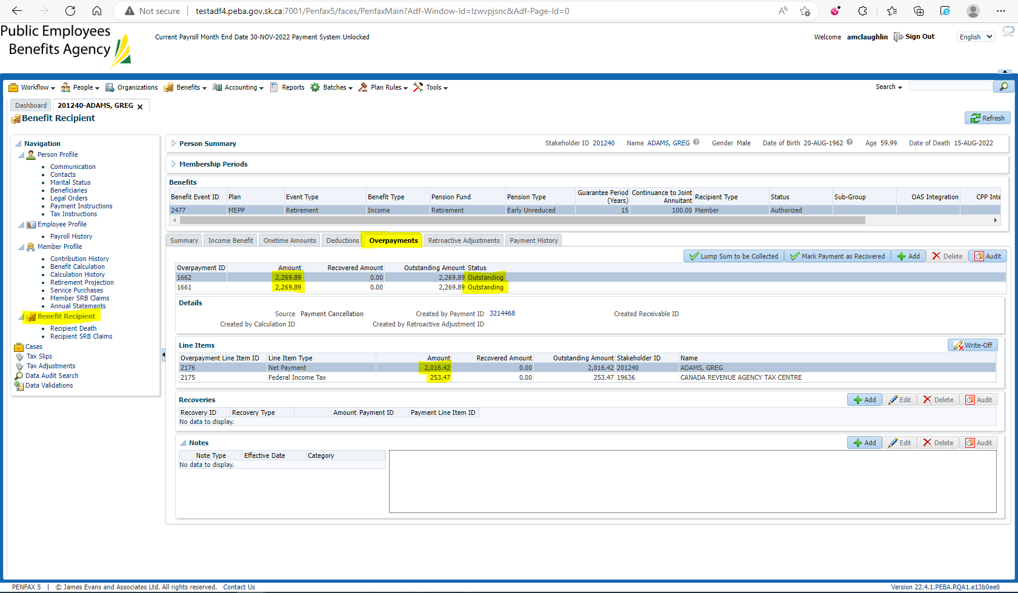

Mark each overpayment in the Lump Sum to be Collected for the Net Payment amount to create receivables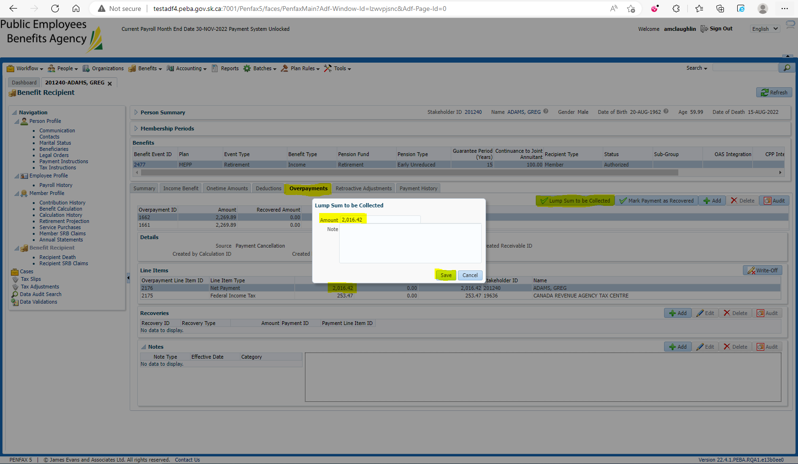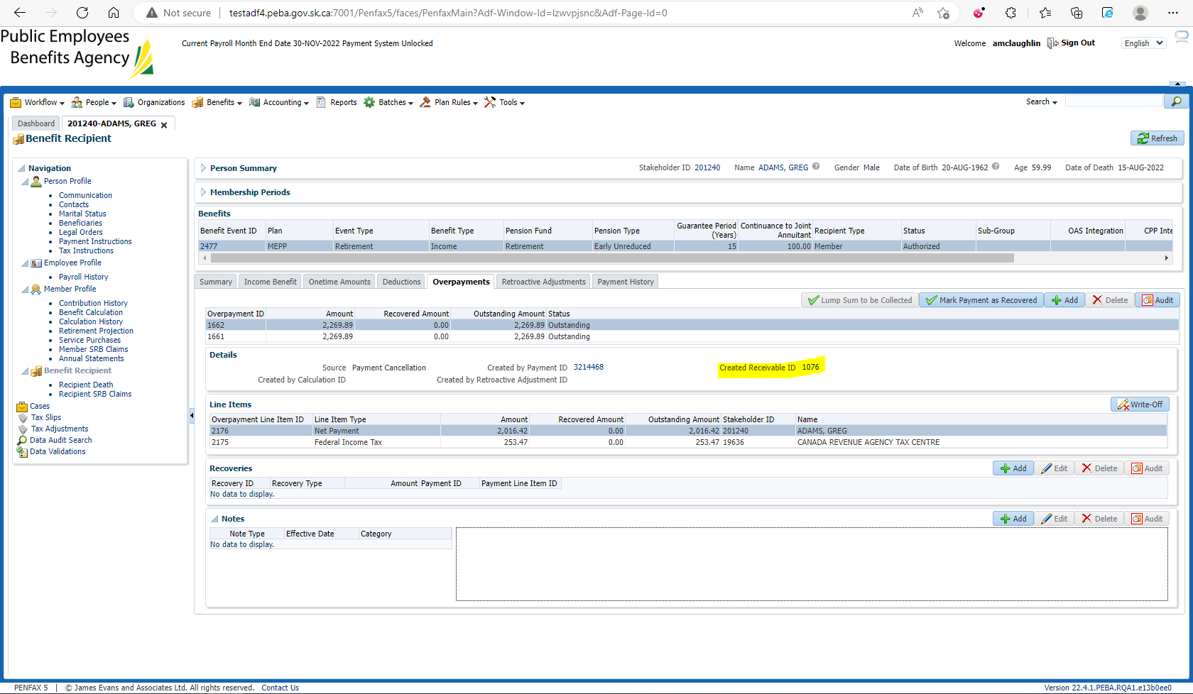

When they mail a cheque in to remit the owed money, a remittance needs to be added for the Net Amounts ($2,016.42 * 2 = $4,032.84) 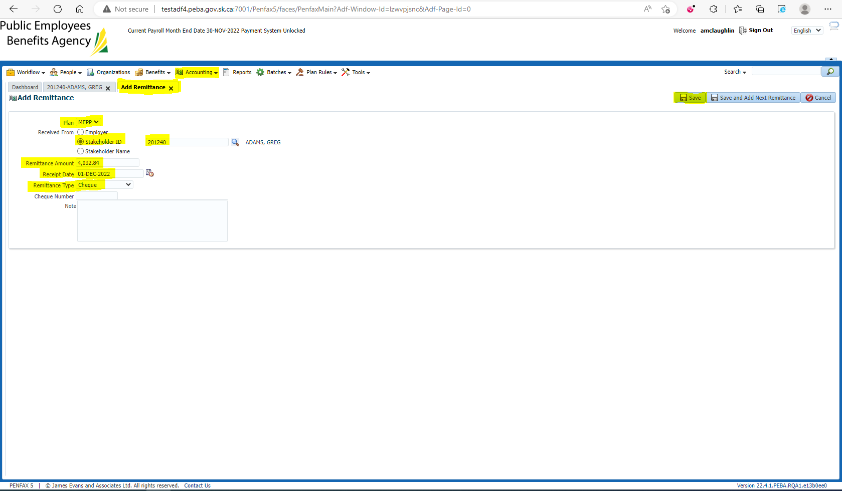

Make note of the remittance ID (47140) 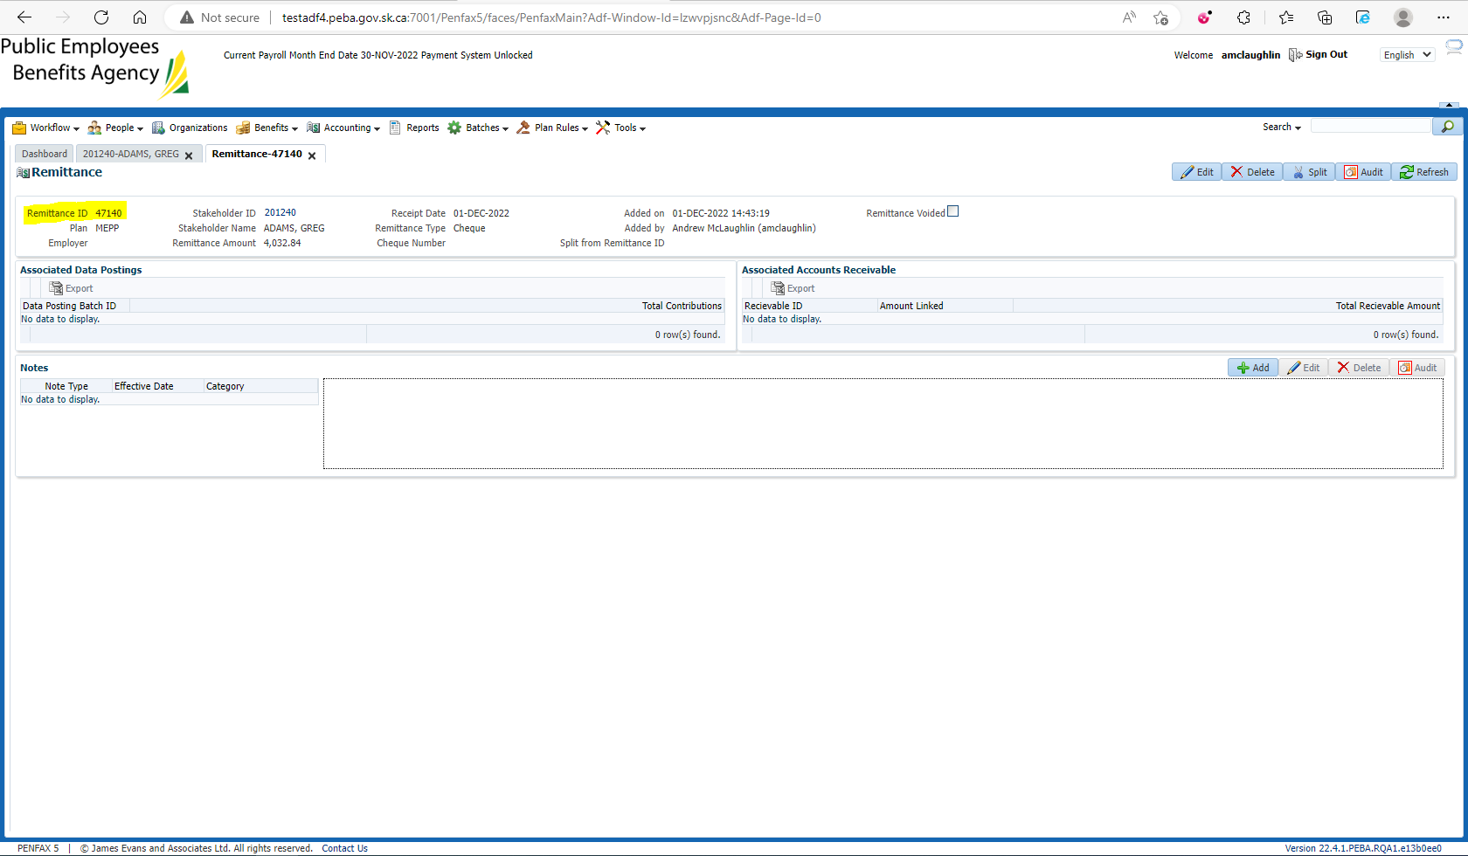

Search and link receivables for each payment missed(2 * $2,016.42) (Numbers from Page 2) 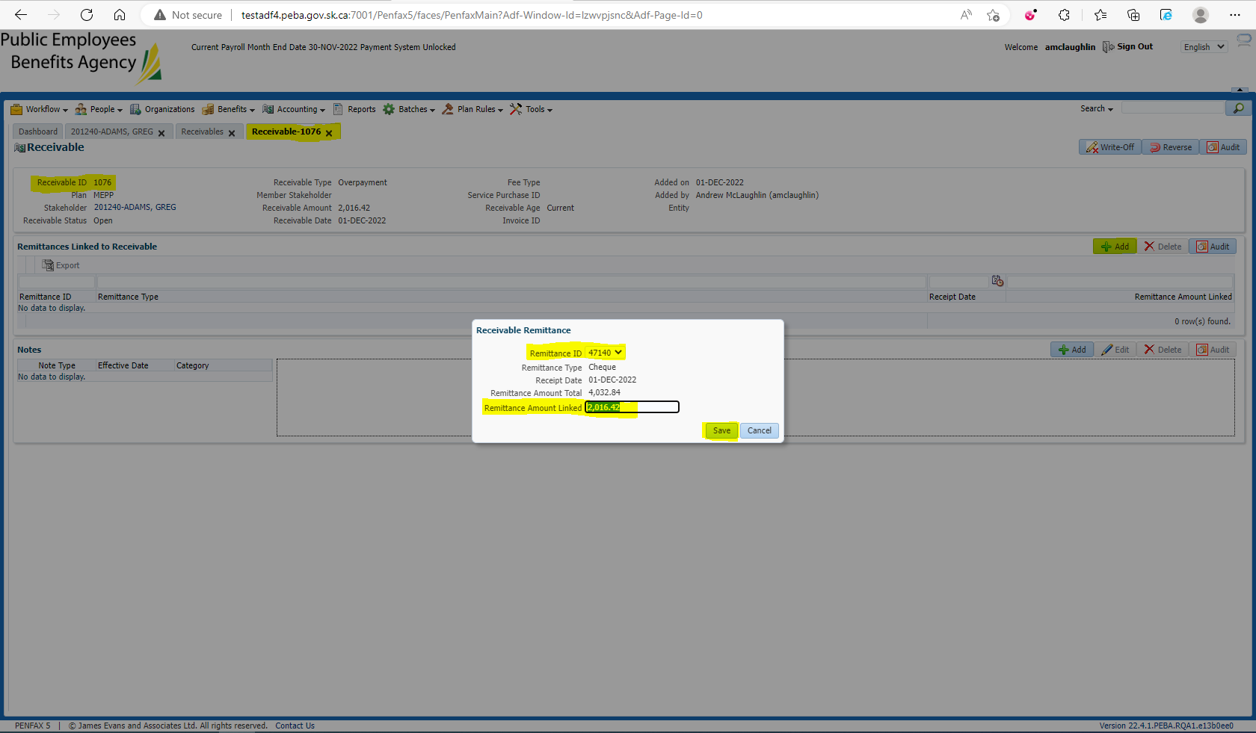

Search up your remittance to ensure all receivables have been linked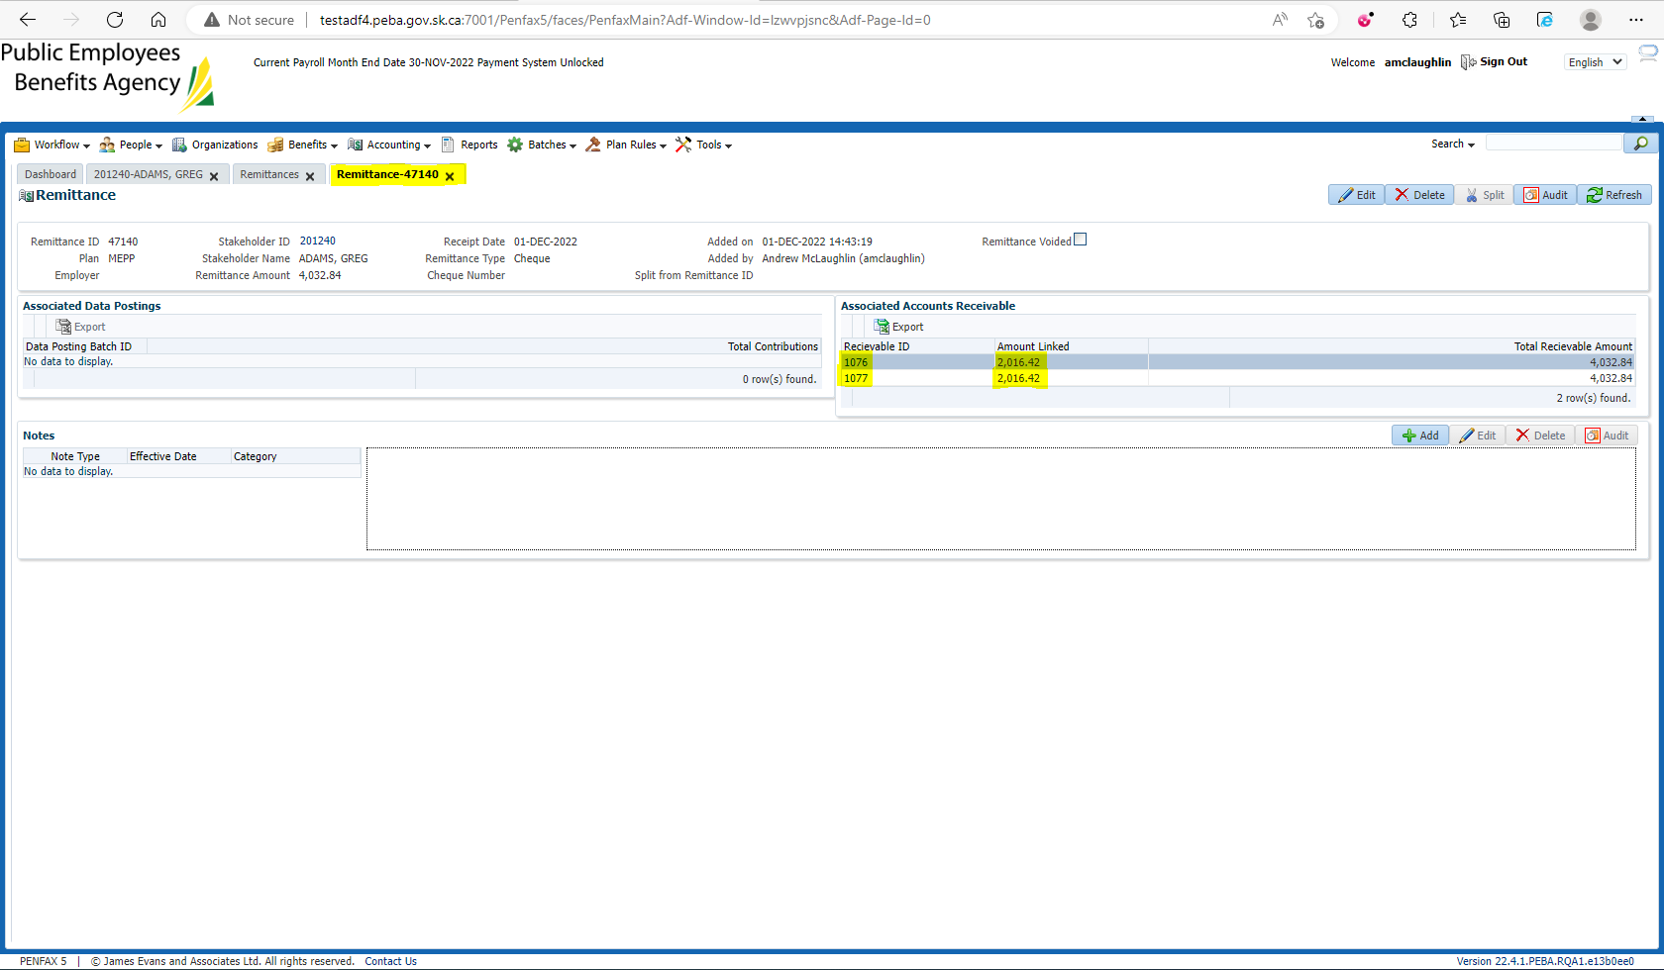

Under the Overpayment tab, create recoveries for overpayment. Net payments get Cheque Received. Tax gets Payable Adjustment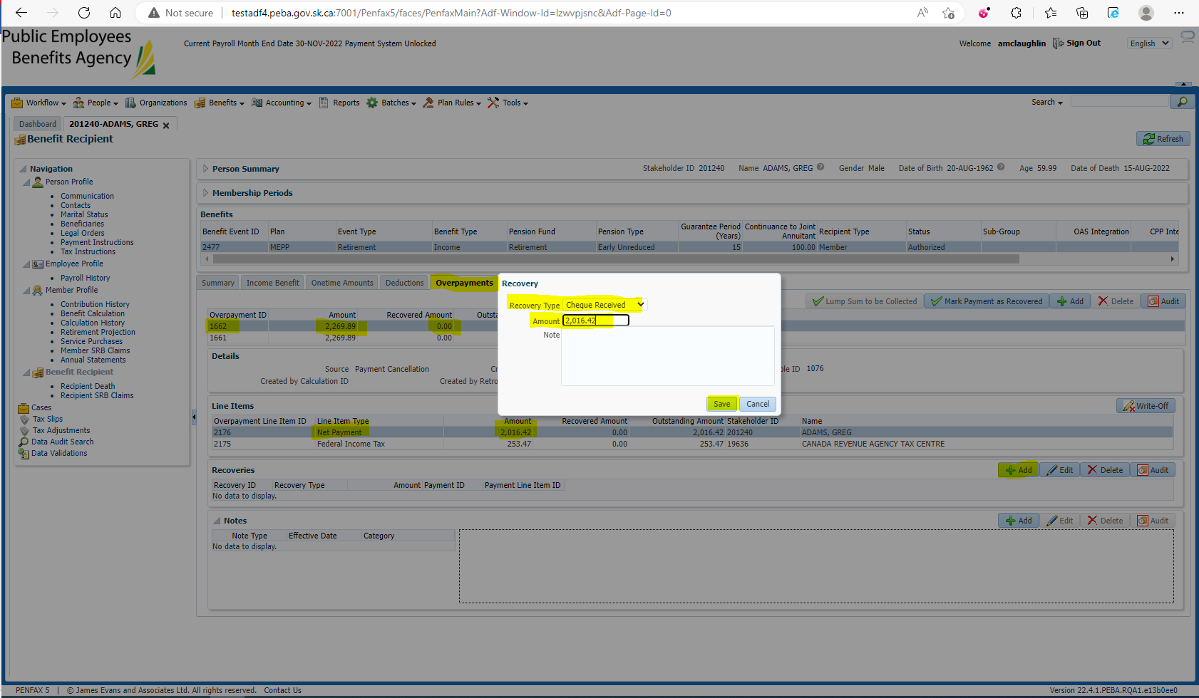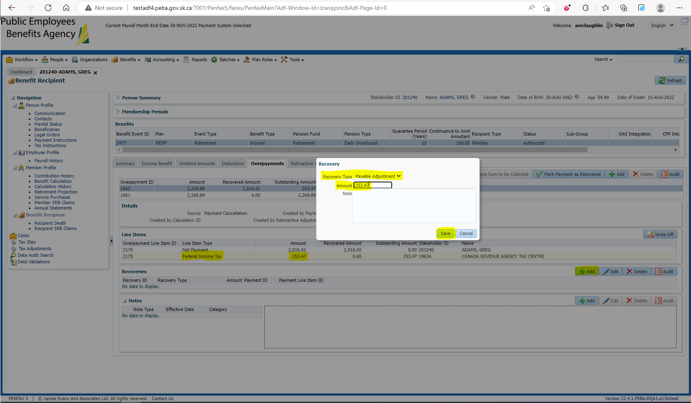

Mark the payment as recovered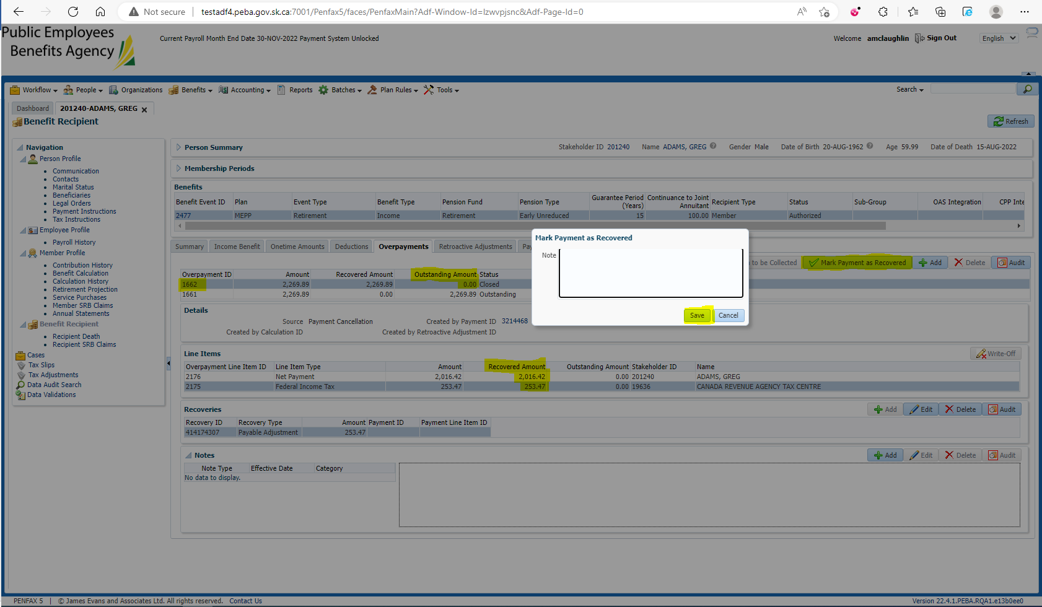

Verify in the Payment History that the Payment has been Recovered